**上机实验6：声明一个SortArray继承类MyArray，在该类中定义一个函数，具有将输入的整数从小到大进行排序的功能**

#include <iostream>

#include <string>

using namespace std;

class MyArray {

public:

MyArray(int length);

~MyArray();

void Input();

void Display(string);

protected:

int* alist;

int length;

};

MyArray::MyArray(int leng) {

if (leng <= 0) {

cout << "error length";

exit(1);

}

alist = new int[length];

length = leng;

if (alist == NULL) {

cout << "assign failure";

exit(1);

}

cout << "MyArray类对象已创建！" << endl;

}

MyArray::~MyArray() {

delete[] alist;

cout << "MyArray类对象已撤销！" << endl;

}

void MyArray::Display(string str) {

int i;

int* p = alist;

cout << str << length << "个整数：";

for (i = 0; i < length; i++, p++) {

cout << *p << "";

}

cout << endl;

}

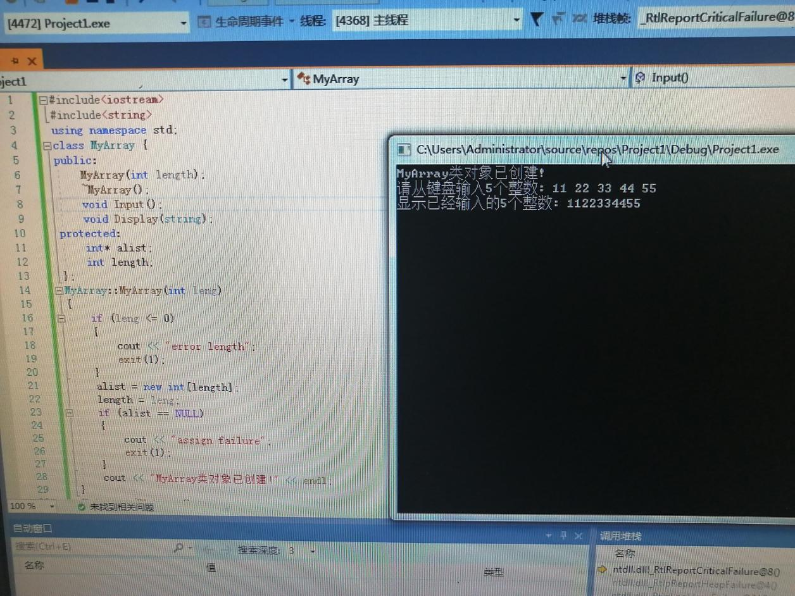

**收获：在上机过程中学习到了继承。学的十分的透彻。了解了继承之间的关系。学习了继承的使用方法。程序结构比较复杂，对于各种括号，必须头脑清晰才能把括号括对。**